OPERATION FALSE ASSURANCE

Team Name | BYEBUST
Phase Number / Title | Phase 2 / OFA P2-02 — First Four Suspicious TLS Destinations  944
Incident Date | 2025-10-03 (UTC)
Date Submitted | 2026-08-22

REPORT SCORING
No. | Category | Percentage | Points
1 | Executive Summary | 10% | 100
2 | Incident Timeline & Attack Reconstruction | 15% | 150
3 | Victim & Infrastructure Identification | 10% | 100
4 | Technical Investigation, Evidence & Attack Analysis | 55% | 550
5 | Containment, Eradication & Recovery Recommendations | 5% | 50
6 | Report Quality & Professional Presentation | 5% | 50
 | TOTAL | 100% | 1,000
Evidence Requirement: Major findings must be supported by Security Onion, Kibana, Elasticsearch, Zeek, Suricata, or other authorized evidence. Unsupported findings may receive no more than 50% of the available points for that finding.

1. EXECUTIVE SUMMARY
10% - 100 Points
Summarize the activity observed during this phase. State what happened, the affected system, the nature of the malicious activity, and the operational significance.
During Phase 2 of Operation False Assurance, security tools found that the computer 10.8.20.101 was hacked/compromised and was communicating with several suspicious servers on the internet.
Two types of malicious activity were found:
- Remote Access Trojan (RAT)
  - The computer was communicating with 38.146.28.242.
  - It used TCP port 1203.
  - The traffic matched NetSupport Manager, a remote-access tool that attackers can use to control a computer.
  - Security monitoring detected this 48 times.
- Information Stealer
  - The computer was also communicating with 79.141.165.202.
  - It used TCP port 80.
  - The traffic matched StealC_V2, malware designed to steal information such as credentials and other sensitive data.
  - It was detected 3 times.
DNS Activity
The computer used 10.8.20.1 as its internal DNS server.
All 6 DNS requests observed from the compromised computer went through this internal DNS server.
Suspicious TLS Connections
The computer also connected to several suspicious domains, in this order:
- dieselfilters.com → 209.59.180.92
- islonline.org → 23.23.49.179
- woop-bicks.com → 172.86.90.13
- cf-2-up.com → 45.61.150.28
- westford-systems.icu
- geo.netsupportsoftware.com

2. INCIDENT TIMELINE AND ATTACK RECONSTRUCTION
15% - 150 Points
Record the significant events in chronological order. Use UTC for all timestamps.
Date / Time (UTC) | Source | Destination | Protocol / Port | Activity / Observation
2025-10-03 09:00:00 UTC | 10.8.20.101 | 209.59.180.92 (dieselfilters.com) | TCP/443 (TLS) | 1st suspicious TLS session (SNI: dieselfilters.com)
2025-10-03 09:00:00 UTC | 10.8.20.101 | 23.23.49.179 (islonline.org) | TCP/443 (TLS) | 2nd suspicious TLS session (SNI: islonline.org)
2025-10-03 09:00:01 UTC | 10.8.20.101 | 172.86.90.13 (woop-bicks.com) | TCP/443 (TLS) | 3rd suspicious TLS session (SNI: woop-bicks.com)
2025-10-03 09:02:19 UTC | 10.8.20.101 | 45.61.150.28 (cf-2-up.com) | TCP/443 (TLS) | 4th suspicious TLS session (SNI: cf-2-up.com)
2025-10-03 ~09:49-09:58 UTC | 10.8.20.101 | 38.146.28.242 | TCP/1203 (HTTP) | NetSupport Manager RAT beacon/check-in traffic (48 events) to /fakeurl.htm
2025-10-03 ~10:02:45 UTC | 10.8.20.101 | 79.141.165.202 | TCP/80 (HTTP POST) | StealC_V2 info-stealer CnC POST activity (3 events)

Attack Reconstruction
Describe how the activity developed during the phase, what the attacker accomplished, and how the available evidence supports the conclusion.

Initial compromise: At around 09:00 UTC, host 10.8.20.101 contacted several suspicious domains, suggesting an initial malware check-in or delivery.

Remote access: Around 09:49–09:58 UTC, the host communicated with 38.146.28.242 using NetSupport Manager, indicating attacker-controlled remote access.

Data theft: At 10:02:45–10:02:46 UTC, the host sent three POST requests to 79.141.165.202, matching StealC information-stealer activity.

Conclusion: 10.8.20.101 was compromised and was used for both remote access and data/credential theft.

Limitation: The exact initial infection method and complete NetSupport timeline were not confirmed.

3. VICTIM AND INFRASTRUCTURE IDENTIFICATION
10% - 100 Points

Affected System
IP Address | 10.8.20.101
Hostname | Not Determined
User Account | Not Determined
Operating System | Likely Microsoft Windows (analyst inference from NetSupport Manager Windows RAT traffic and SMB/NetBIOS activity in the broader alert set - not confirmed)
Active Directory Domain | Not Determined
System Role | Workstation (per exercise scenario: "Infected Workstation")
Status | Confirmed Compromised - NetSupport Manager RAT and StealC_V2 info-stealer C2 traffic confirmed via Suricata alerts and Zeek logs
Status: Confirmed Compromised / Suspected Compromised / Targeted / Scanned / Not Determined

Relevant Infrastructure
Type | Domain / IP Address | Port | Purpose / Observation
C2 - Remote Access Tool | 38.146.28.242 | 1203 | NetSupport Manager RAT check-in beacon (CMD=POLL/ENCD to /fakeurl.htm)
C2 - Information Stealer | 79.141.165.202 | 80 | StealC_V2 CnC POST activity
Suspicious TLS Destination | dieselfilters.com (209.59.180.92) | 443 | 1st suspicious TLS SNI contacted by infected host
Suspicious TLS Destination | islonline.org (23.23.49.179) | 443 | 2nd suspicious TLS SNI contacted
Suspicious TLS Destination | woop-bicks.com (172.86.90.13) | 443 | 3rd suspicious TLS SNI contacted
Suspicious TLS Destination | cf-2-up.com (45.61.150.28) | 443 | 4th suspicious TLS SNI contacted
Internal DNS Resolver | 10.8.20.1 | 53 | DNS resolver used by infected host for all 6/6 observed queries

4. TECHNICAL INVESTIGATION, EVIDENCE AND ATTACK ANALYSIS
55% - 550 Points
This section contains the main technical findings. Each significant conclusion should be supported by evidence.

4.1 Analyst Findings
No. | Finding / Objective | Answer / Result | Evidence Ref.
1 | Identify the infected workstation IPv4 address | 10.8.20.101 | Figures 1-2
2 | Identify the DNS resolver used by the infected workstation | 10.8.20.1 (6 of 6 observed DNS queries resolved via this internal resolver) | Figures 3-4
3 | Identify the first four suspicious TLS server names (SNI) and resolved IPv4 addresses, in chronological order | 1) dieselfilters.com -> 209.59.180.92 2) islonline.org -> 23.23.49.179 3) woop-bicks.com -> 172.86.90.13 4) cf-2-up.com -> 45.61.150.28 | Figure 6

4.2 Malware / Tool Identification
Malware / Tool / Technique | Evidence | Confidence
NetSupport Manager v1.3 (legitimate remote-support tool abused as a RAT) | Suricata rule "ET REMOTE_ACCESS NetSupport Remote Admin Checkin" (48 hits); HTTP User-Agent "NetSupport Manager/1.3"; CMD=POLL/CMD=ENCD beacons to 38.146.28.242:1203/fakeurl.htm (Figures 1-2) | High
StealC V2 (information-stealer malware) | Suricata rule "ET MALWARE StealC_V2 CnC Activity (POST)" (3 hits) to 79.141.165.202:80 (Figures 1, 5) | High
Possible Dridex banking trojan (JA3 hash match) | Suricata rule "ET JA3 Hash - [Abuse.ch] Possible Dridex" (66 hits) present in the same sensor dataset; not yet correlated to source IP 10.8.20.101 - requires further validation | Medium (association with this host Not Determined)
Technical analysis:
- NetSupport: The traffic used HTTP commands on TCP port 1203 and repeatedly connected to /fakeurl.htm. This pattern is consistent with NetSupport RAT activity rather than normal IT support.
- StealC: The host repeatedly sent short HTTP POST requests to an external IP on TCP port 80, consistent with data theft and malware check-ins.

4.3 Network Activity
Time (UTC) | Source IP | Destination IP | Port | Protocol | Domain / Host | Observation
2025-10-03 09:00:00 UTC | 10.8.20.101 | 209.59.180.92 | 443 | TLS | dieselfilters.com | 1st suspicious TLS session (Zeek ssl.log)
2025-10-03 09:00:00 UTC | 10.8.20.101 | 23.23.49.179 | 443 | TLS | islonline.org | 2nd suspicious TLS session
2025-10-03 09:00:01 UTC | 10.8.20.101 | 172.86.90.13 | 443 | TLS | woop-bicks.com | 3rd suspicious TLS session (2 connections observed)
2025-10-03 09:02:19 UTC | 10.8.20.101 | 45.61.150.28 | 443 | TLS | cf-2-up.com | 4th suspicious TLS session (2 connections observed)
Analysis:
- TLS connections: The infected host 10.8.20.101 connected to four external domains over HTTPS (port 443). Zeek DNS and SSL logs confirmed the domains were resolved and contacted in the same order.
- Later activity: Around 09:12:56 UTC, the host also queried westford-systems.icu and geo.netsupportsoftware.com. The second domain appears related to NetSupport Manager and may have been involved in delivering or updating the RAT.

4.4 Command-and-Control Activity
C2 Domain / IP | Port | Protocol | First Seen | Observation
38.146.28.242 | 1203 | HTTP | ~2025-10-03 09:49 UTC (earliest of most-recent 10 of 48 events reviewed; exact first-seen pending full pagination review) | NetSupport Manager RAT beacon (CMD=POLL, CMD=ENCD) to /fakeurl.htm
79.141.165.202 | 80 | HTTP (POST) | 2025-10-03 ~10:02:45 UTC | StealC_V2 info-stealer CnC POST activity
cf-2-up.com / 45.61.150.28 | 443 | HTTPS/TLS | 2025-10-03 09:02:19 UTC | Suspicious TLS destination among the first four resolved by the infected host; not yet confirmed as active C2 vs. additional stager/redirector
Assessment:
Two active C2 channels were confirmed on the same infected host:
- NetSupport RAT → 38.146.28.242:1203
- StealC info-stealer → 79.141.165.202:80
The suspicious TLS domains may have been used for malware staging or redirection, but this was not confirmed as active C2.

4.5 Files and Payloads
Filename | Source / URL | Type | Observation
Not Determined | Not Determined | Not Determined | File/payload retrieval (dropper, second-stage binary) was not confirmed in this investigation pass; ET INFO PE EXE or DLL Windows file download HTTP and ET INFO SMB Executable File Transfer alerts exist in the broader dataset but have not yet been correlated to 10.8.20.101 specifically.
Use “Not Determined” when the exact filename or content cannot be confirmed from the available evidence.

4.6 Credential Collection / Exfiltration
Collection Method | Not Determined - StealC_V2 is a known browser-credential/cookie/crypto-wallet stealer; the specific collection method on this host was not confirmed from network metadata alone.
Information Collected | Not Determined (see above)
Exfiltration Method | HTTP POST to malware C2 (ET MALWARE StealC_V2 CnC Activity)
Destination | 79.141.165.202
Protocol / Port | TCP/80 (HTTP POST)
Three StealC_V2-signature POST requests from 10.8.20.101 to 79.141.165.202:80 were confirmed (~10:02:45-10:02:46 UTC), consistent with an information-stealer transmitting harvested data to its C2 server (Figure 5). Packet payload content was not decoded in this pass.

4.7 Lateral Movement
Time (UTC) | Source | Destination | Port / Protocol | Activity
Not Determined | Not Determined | Not Determined | SMB/445 (tentative) | GPL NETBIOS SMB-DS IPC$ unicode/share-access alerts observed in the broader sensor dataset (53 + 40 events) - not yet correlated to 10.8.20.101; requires further investigation before lateral movement can be confirmed or ruled out.
State whether the destination was merely contacted, targeted, or confirmed compromised.
No lateral movement from 10.8.20.101 was confirmed in this investigation pass.

4.8 Ransomware Activity
No ransomware activity was identified for 10.8.20.101 in this investigation pass.

4.9 Indicators of Compromise
Indicator | Type | Purpose / Assessment | Recommended Action
10.8.20.101 | IPv4 (internal host) | Infected workstation | Isolate host; initiate endpoint forensics
10.8.20.1 | IPv4 (internal host) | DNS resolver used by the infected host | Review resolver logs for additional lookups from this and other hosts
38.146.28.242:1203 | C2 IP:Port | NetSupport Manager RAT command-and-control | Block at perimeter firewall/proxy; add to blocklist
79.141.165.202:80 | C2 IP:Port | StealC_V2 information-stealer command-and-control | Block at perimeter firewall/proxy; add to blocklist
dieselfilters.com, islonline.org, woop-bicks.com, cf-2-up.com | Domain (suspicious TLS SNI) | First four suspicious TLS destinations contacted by the infected host | Block/sinkhole domains; monitor DNS for repeat resolution
westford-systems.icu, geo.netsupportsoftware.com | Domain (suspicious TLS SNI, observed later) | 5th/6th TLS SNI queried by the infected host, after the first four | Block/sinkhole domains; investigate association with NetSupport RAT infrastructure

4.10 Investigation Evidence
Query / Filter Used:
Security Onion Hunt (Elasticsearch): rule.name:"ET REMOTE_ACCESS NetSupport Remote Admin Checkin" | groupby source.ip destination.ip (time range: last 365 days)

Finding:
All 48 matching events originate from a single source.ip, 10.8.20.101, to a single destination.ip, 38.146.28.242:1203 - confirming 10.8.20.101 as the infected workstation generating NetSupport RAT beacon traffic.

Evidence Reference: Figure 2
Kibana / Elasticsearch
Alerts / Suricata
Time (UTC) | Alert | Source | Destination | Remarks
2025-10-03 ~09:49-09:58 UTC (48 events) | ET REMOTE_ACCESS NetSupport Remote Admin Checkin | 10.8.20.101:63910 | 38.146.28.242:1203 | Confirms RAT C2 channel; User-Agent NetSupport Manager/1.3
2025-10-03 ~10:02:45-10:02:46 UTC (3 events) | ET MALWARE StealC_V2 CnC Activity (POST) | 10.8.20.101:63958 | 79.141.165.202:80 | Confirms info-stealer C2 channel
Not yet correlated to this host | ET JA3 Hash - [Abuse.ch] Possible Dridex (66 events, dataset-wide) | Not Determined | Not Determined | Requires further investigation to confirm/rule out relation to 10.8.20.101
Zeek Logs Used
- [x] conn
- [x] dns
- [x] http
- [x] ssl / tls
- [ ] smtp
- [ ] files
- [ ] dhcp
- [ ] kerberos
- [ ] smb
- [ ] other: Suricata eve.json alerts (imported)
Relevant observation:
The zeek.dns groupby (Figures 3-4) shows all 6 DNS queries from 10.8.20.101 resolved via internal DNS server 10.8.20.1, and the zeek.ssl query (Figure 6) independently confirms the first four suspicious TLS server names in chronological order, corroborating the dns.query.name values seen in the DNS log.

4.11 Evidence Register
Evidence No. | Description | Source
E-01 | Security Onion Alerts, grouped by rule name, Last 365 days - shows ET REMOTE_ACCESS NetSupport Remote Admin Checkin (48 events) and ET JA3 Hash Possible Dridex (66 events) among the full alert list, with query bar and totals visible. | Security Onion
E-02 | Security Onion Hunt (Elasticsearch-backed) grouped query confirming source.ip 10.8.20.101 as the sole originator of NetSupport RAT beacon traffic to 38.146.28.242 (48/48 events). | Kibana
E-03 | Suricata alert grouping for ET MALWARE StealC_V2 CnC Activity (POST) confirming source.ip 10.8.20.101 -> destination.ip 79.141.165.202:80 (3/3 events). | Suricata
E-04 | Zeek dns.log query (event.dataset:zeek.dns) confirming all 6 DNS queries from 10.8.20.101 were resolved via internal DNS server 10.8.20.1. | Zeek
E-05 | Zeek ssl.log query (event.dataset:zeek.ssl) - full chronological listing of the 6 TLS sessions from 10.8.20.101, showing the first four unique suspicious TLS server names (SNI) and their resolved destination IPs. | Other
E-06 | Zeek dns.log full event listing (dns.query.name) corroborating the four suspicious domains identified via TLS SNI, plus two later domains (westford-systems.icu, geo.netsupportsoftware.com). | Zeek
Each screenshot should include a short caption explaining what it shows.

4.12 MITRE ATT&CK Mapping
Tactic | Technique | Technique ID | Evidence
Command and Control | Remote Access Software | T1219 | NetSupport Manager RAT beacon traffic to 38.146.28.242:1203 (Figure 2)
Command and Control | Application Layer Protocol: Web Protocols | T1071.001 | HTTP-based C2 for both NetSupport (fakeurl.htm) and StealC_V2 (POST) (Figures 2, 5)
Credential Access / Collection | Credentials from Password Stores (tentative) | T1555 | StealC_V2 is a known credential/browser-data stealer; specific collection method not yet confirmed on this host
Command and Control | Encrypted Channel (TLS) | T1573.002 | Four suspicious TLS sessions to dieselfilters.com, islonline.org, woop-bicks.com, cf-2-up.com (Figure 6)

5. CONTAINMENT, ERADICATION AND RECOVERY
5% - 50 Points
Provide recommendations based on the findings from this phase.

Immediate Actions
1. Isolate host 10.8.20.101 from the network to stop further C2 communication and possible data exfiltration.
2. Block/sinkhole C2 indicators at the perimeter: 38.146.28.242:1203, 79.141.165.202:80, and the domains dieselfilters.com, islonline.org, woop-bicks.com, cf-2-up.com.
3. Preserve host memory/disk for forensic imaging before remediation; capture running-process and persistence-mechanism evidence related to NetSupport Manager.

Additional Recommendations
Network:
Add all identified C2 IPs/domains to firewall, proxy, and DNS sinkhole blocklists; enable alerting on any future NetSupport Manager or StealC_V2 signature matches.
Endpoint:
Deploy EDR/AV scan on 10.8.20.101 and any peer hosts; remove NetSupport Manager if not authorized for legitimate remote support use; hunt for the same IOCs across the environment.
Accounts / Credentials:
Force password reset for any accounts used on 10.8.20.101, and for any credentials that may be stored in browsers on that host, given StealC_V2's credential-theft capability.
Active Directory, if applicable:
Not Determined - AD domain membership of 10.8.20.101 was not confirmed in this investigation pass; if domain-joined, review for anomalous authentication from this host.
Recovery:
Reimage 10.8.20.101 from a known-good baseline after forensic evidence collection is complete; restore from backup only after confirming backups predate the compromise window.

6. CONCLUSION
Provide the team’s final assessment of the phase. State what happened, what system was affected, what the attacker accomplished, the evidence supporting the conclusion, the impact, and how this phase relates to the larger incident.
During this phase, internal workstation 10.8.20.101 was confirmed compromised, exhibiting both remote-access trojan (NetSupport Manager) and information-stealer (StealC_V2) command-and-control traffic.
The host relied exclusively on internal DNS resolver 10.8.20.1, and its first four suspicious TLS destinations, in chronological order, were dieselfilters.com (209.59.180.92), islonline.org (23.23.49.179), woop-bicks.com (172.86.90.13), and cf-2-up.com (45.61.150.28).
This activity is consistent with Phase 2's stated theme of "Remote Access and Information-Stealer Traffic" and demonstrates that the attacker had both hands-on-keyboard remote access capability and an active data-theft channel on the victim host.
The impact includes potential loss of credentials, browser-stored data, and system information, plus the risk of further lateral movement or ransomware staging enabled by the RAT foothold.
These findings should be correlated with Phase 1 (initial access/exploitation, e.g. ETERNALBLUE/DOUBLEPULSAR and Emotet activity observed in the same sensor dataset) to build a complete attack timeline for the incident.

7. EVIDENCE LIMITATIONS
List any information that could not be confirmed from the available data. Do not present assumptions as confirmed facts.
The exact first-seen and last-seen timestamps for the full 48-event NetSupport RAT beacon session were not individually enumerated beyond the most recent 10 events reviewed; only the observed window (~09:49-09:58 UTC) is confirmed.
Hostname, logged-on user account, operating system version, and Active Directory domain membership for 10.8.20.101 could not be confirmed from the network metadata reviewed in this pass; OS family (Windows) is inferred, not confirmed.
The relationship between the "ET JA3 Hash - Possible Dridex" alerts (66 events) and host 10.8.20.101 has not yet been confirmed or ruled out.
File/payload artifacts, exact credential-collection method, and lateral-movement scope for this host were not confirmed in this investigation pass.

8. APPENDICES

Appendix A - Investigation Queries
Query:
Security Onion Hunt: rule.name:"ET REMOTE_ACCESS NetSupport Remote Admin Checkin" | groupby source.ip destination.ip (Last 365 days) - identifies the infected workstation IP via the RAT beacon.
Query:
Security Onion Hunt: event.dataset:zeek.dns && source.ip:10.8.20.101 | groupby destination.ip (Last 365 days) - identifies the DNS resolver used by the infected workstation.

Query:
Security Onion Hunt: event.dataset:zeek.ssl && source.ip:10.8.20.101 (Last 365 days, sorted by Timestamp ascending) - identifies the first four suspicious TLS server names (SNI) and their resolved destination IPs.

Appendix B - Figures and Screenshots
Use sequential figure numbers. Each figure should include a short caption describing what the evidence demonstrates.
Figure 1

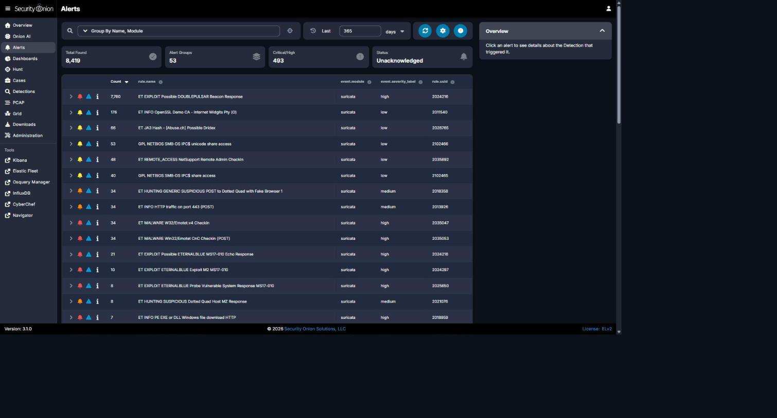
Security Onion Alerts, grouped by rule name (Last 365 days) - NetSupport Remote Admin Checkin (48) and Possible Dridex (66) visible with query bar and totals.
Figure 2

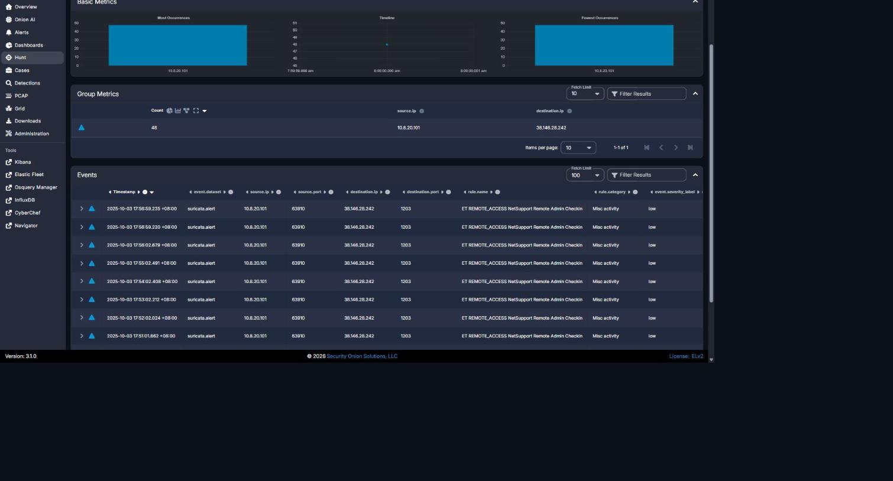
Security Onion Hunt - NetSupport rule grouped by source.ip/destination.ip: 48/48 events, 10.8.20.101 -> 38.146.28.242:1203.
Figure 3

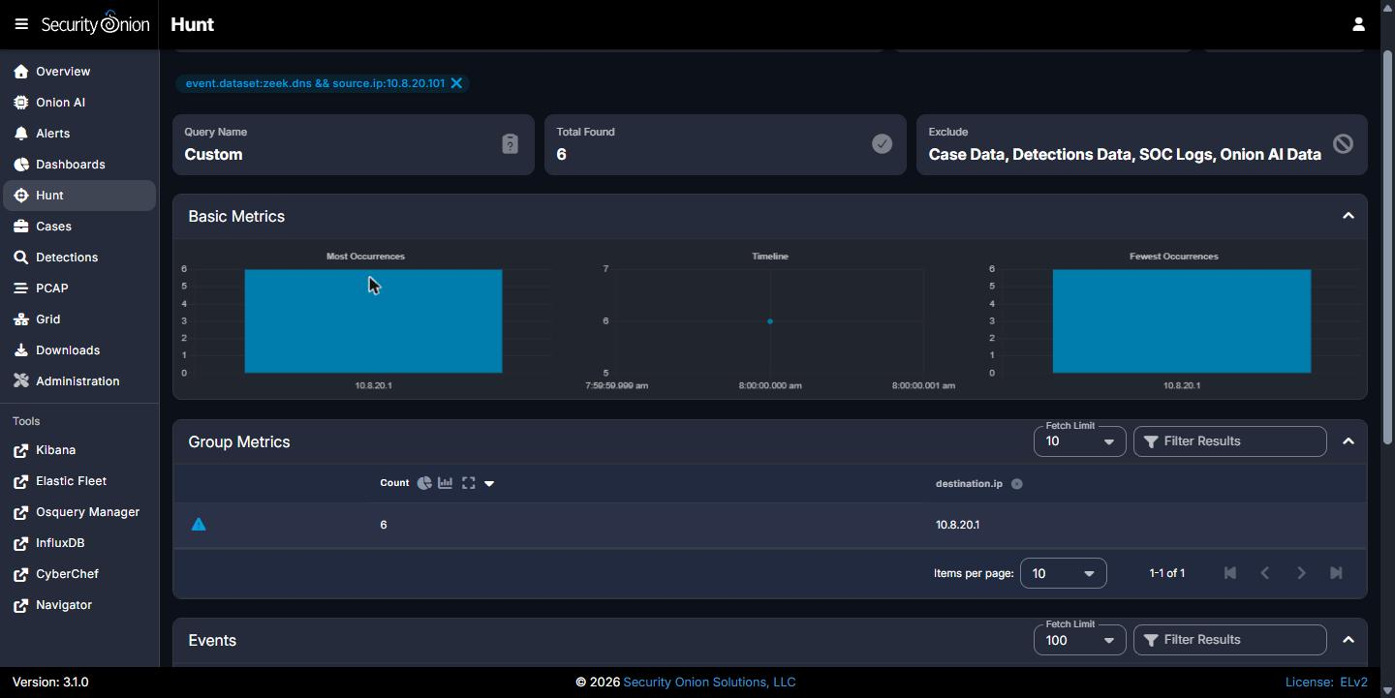
Security Onion Hunt - zeek.dns from 10.8.20.101 grouped by destination.ip: Total Found 6, sole resolver 10.8.20.1.
Figure 4
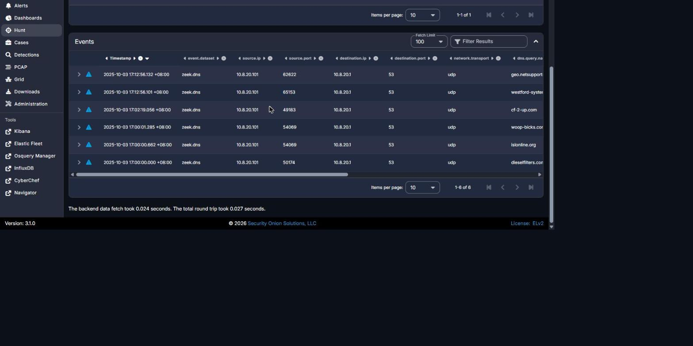
Security Onion Hunt - zeek.dns Events table: all 6 DNS queries with timestamps and dns.query.name.
Figure 5
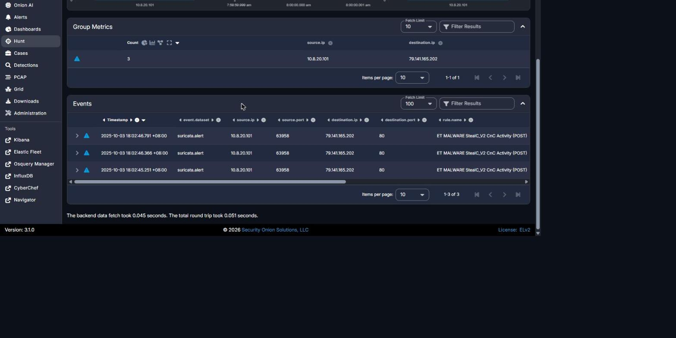
Security Onion Hunt - StealC_V2 rule grouped by source.ip/destination.ip: 3/3 events, 10.8.20.101 -> 79.141.165.202:80.
Figure 6
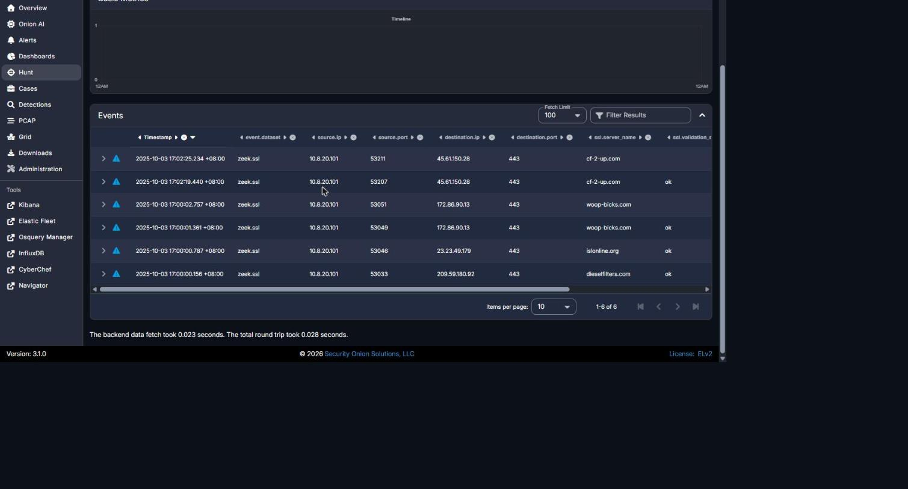
Security Onion Hunt - zeek.ssl from 10.8.20.101: full chronological listing of all 6 TLS sessions with ssl.server_name and destination.ip.
Figure | Caption / Description
Figure 1 | Security Onion Alerts, grouped by rule name (Last 365 days) - shows ET REMOTE_ACCESS NetSupport Remote Admin Checkin (48 events) and ET JA3 Hash Possible Dridex (66 events) among the full alert list, with query bar, time range, and totals visible.
Figure 2 | Security Onion Hunt - rule.name "ET REMOTE_ACCESS NetSupport Remote Admin Checkin" grouped by source.ip/destination.ip: confirms 48/48 events from 10.8.20.101 to 38.146.28.242:1203.
Figure 3 | Security Onion Hunt - event.dataset:zeek.dns && source.ip:10.8.20.101 grouped by destination.ip: Total Found = 6, Group Metrics confirms sole DNS resolver 10.8.20.1.
Figure 4 | Security Onion Hunt - same query, Events table listing all 6 DNS queries (timestamps and dns.query.name) resolved via 10.8.20.1.
Figure 5 | Security Onion Hunt - rule.name "ET MALWARE StealC_V2 CnC Activity (POST)" grouped by source.ip/destination.ip: confirms 3/3 events from 10.8.20.101 to 79.141.165.202:80.
Figure 6 | Security Onion Hunt - event.dataset:zeek.ssl && source.ip:10.8.20.101: full chronological listing of the 6 TLS sessions with ssl.server_name and destination.ip - source for the first four suspicious TLS destinations.

REPORT QUALITY REQUIREMENTS
5% - 50 Points
- Clear and logical organization
- Correct technical terminology
- Accurate use of timestamps
- Readable screenshots
- Properly labeled tables and figures
- Consistent evidence references
- Clear distinction between confirmed facts and analyst inference
- Professional presentation and readability

SUBMISSION INSTRUCTIONS
1. Submit one report for each phase designated as Report-Required.
2. Submit the final report in PDF format unless otherwise directed.
3. Clearly indicate the team name, phase number, and phase title.
4. Use UTC for timestamps.
5. Major findings must be supported by evidence.
6. Screenshots must be numbered and captioned.
7. Do not include executable malware samples in the report.
8. State 'Not Determined' when a finding cannot be confirmed.
9. Ensure all screenshots, tables, and text are readable.
10. Reports must be submitted before the deadline announced by exercise control.
Evidence Rule: A correct finding without supporting Security Onion, Kibana, Elasticsearch, Zeek, Suricata, or other authorized evidence may receive no more than 50% of the points assigned to that finding. Incorrect or fabricated evidence receives zero points for the affected finding.

